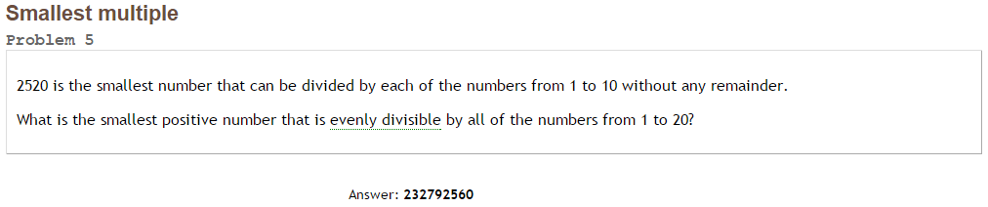Project Euler #5 – Pen & Paper Solution

The smallest number that can be divided by set of numbers, is the product of the primes generating the set, each by the max power exists.

For example: set = {1, 2, 3, 4, 5, 6, 7, 8, 9, 10} =  
 

|  |  |
| --- | --- |
| Prime: | Max power: |
| 2 | 3 |
| 3 | 2 |
| 5 | 1 |
| 7 | 1 |

Smallest number: [2520](http://www.wolframalpha.com/input/?i=2%5E3*3%5E2*5*7)

We will do the same, with set = {1, 2, 3, 4, 5, 6, 7, 8, 9, 10, 11, 12, 13, 14, 15, 16, 17, 18, 19, 20} =



|  |  |
| --- | --- |
| Prime: | Max power: |
| 2 | 4 |
| 3 | 2 |
| 5 | 1 |
| 7 | 1 |
| 11 | 1 |
| 13 | 1 |
| 17 | 1 |
| 19 | 1 |

Smallest number: [232792560](http://www.wolframalpha.com/input/?i=2%5E4++3%5E2+5+7+11+13+17+19)